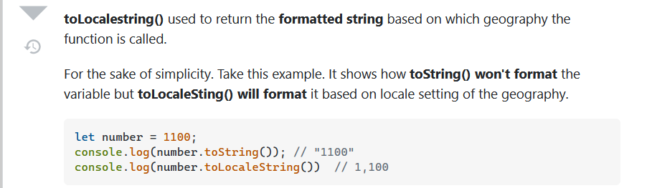

So basically toLocaleString( ) will return value based on the system of that geography from where the method is being called

